1. *Electrical and electronic technology*

-The different features of electrification and informatization

Electrification is based on the distribution box as the distribution center, the comprehensive wiring of strong electric cable, from the function, capacity, safety, convenience and other aspects to meet the needs of the family.

Informatization is based on weak current distribution box as the center, all kinds of weak current signal cables for comprehensive wiring, so that the home becomes a convenient information sending and receiving platform. The concept of integrated cabling here is to unite strong and weak electricity to be considered comprehensively, so as to establish connections between strong electricity network and weak electricity network and create favorable conditions for intelligent transition.

Electrification means the widely usage of electricity in all kinds of parts of the national economy and in people’s life. Its features are as followed

1. the electric power is produced all together, and the whole country have one nationally unified high voltage network.
2. It is influenced by nature, economy and the society.
3. The level of the electrification is different in different areas.

Informatization means that to cultivate and develop new productive forces represented by computer-based intelligent tools, and use them to benefit the society. Its features are as followed

1. Informatization is a process of improving the productivity of knowledge and information caused by the improvement of people's education level.
2. It is the widely use on information technology in various fields of politics, economy, culture and social life.
3. It is to use modern information technology to achieve information resource sharing and to solve various problems in society and economy.

- one pioneering scientist or engineer who has made significant contributions towards electrification or informatization

Alan Mathison Turing

- the working principle of

discovery or invention and its relation to electrical engineering

1. He put forward the concept of general computer
2. Propose the Turing test

One of the greatest contribution is that Turing put forward the Turing test. It can identify whether the machine, or the program have the human intelligence. Also, his famous Turing machine model laid the foundation for the logical way modern computers work.

*2.Linear resistive network*

-the I-V characteristics of a current source and a voltage source

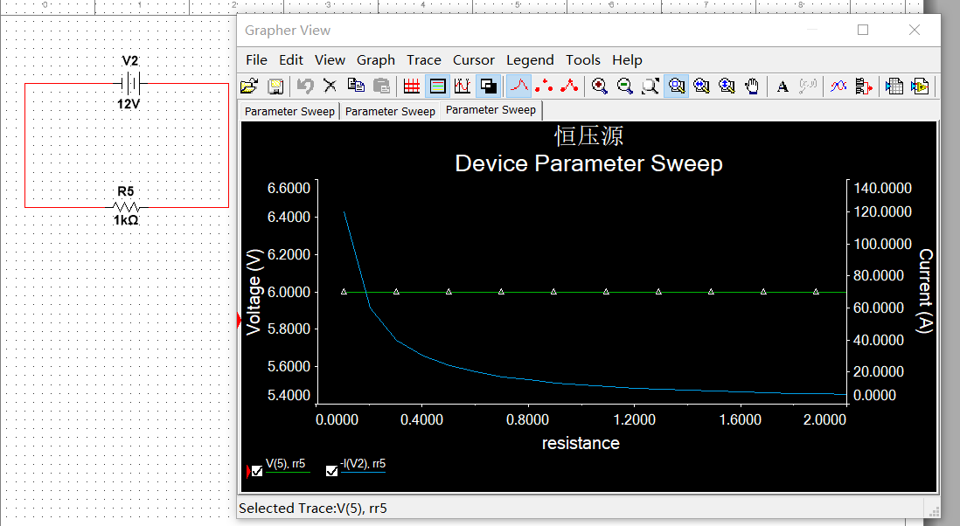

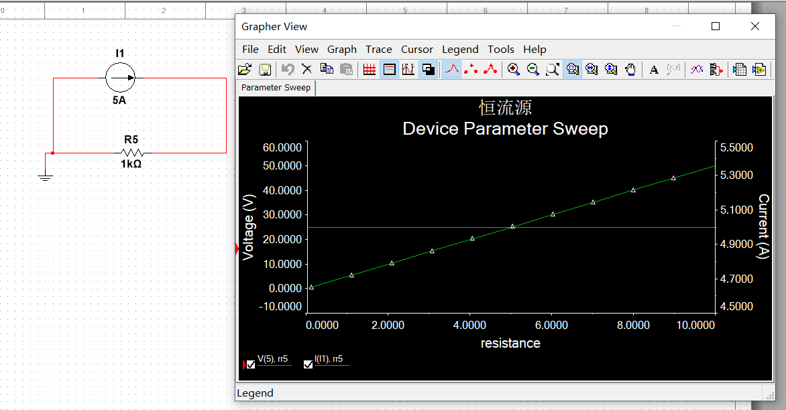

-use multisim simulation tool

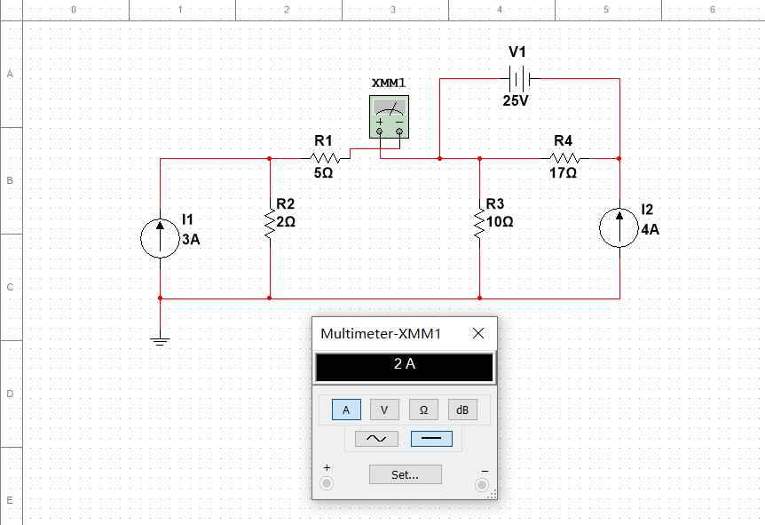

I1=2A

- use superposition principle

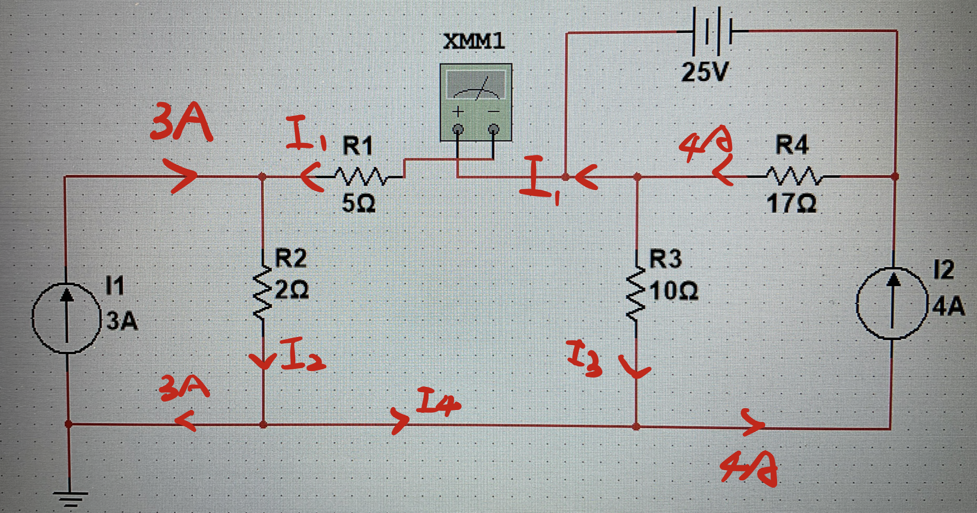

3A+I1=I2

I2=3A+I4

I3+I4=4A

I1+I3=4A

I1=2A

I2=5A

I3=2A

I4=2A

-more information about superposition in circuit analysis

The superposition principle of a circuit says that the output of a circuit is the sum of the outputs produced by each source acting independently.

*3.Transistor characteristics*

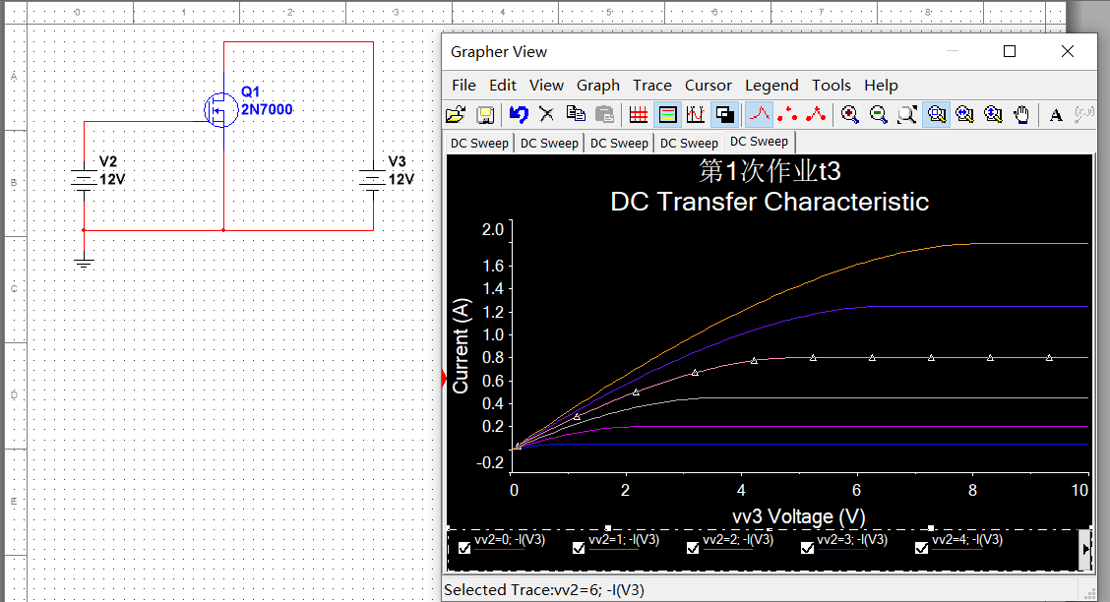

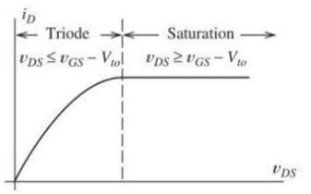

To make the NMOS off: let the VDS<=VGS-Vto

To make the NMOS off: let the VDS>=VGS-Vto

*4.MCU development*

*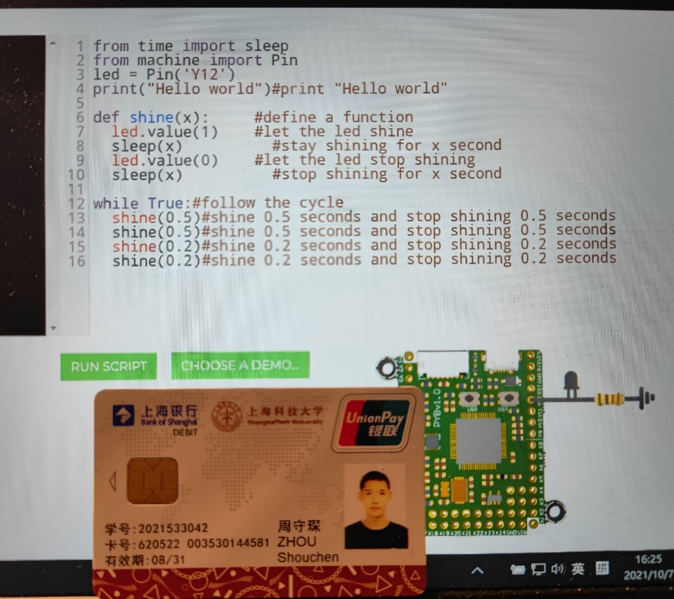*

from time import sleep

from machine import Pin

led = Pin(2,Pin.OUT)

print("Hello world")#print "Hello world"

def shine(x): #define a function

led.value(1) #let the led shine

sleep(x) #stay shining for x second

led.value(0) #let the led stop shining

sleep(x) #stop shining for x second

while True:#follow the cycle

shine(0.5)#shine 0.5 seconds and stop shining 0.5 seconds

shine(0.5)#shine 0.5 seconds and stop shining 0.5 seconds

shine(0.2)#shine 0.2 seconds and stop shining 0.2 seconds

shine(0.2)#shine 0.2 seconds and stop shining 0.2 seconds